Authentic Writing Assignment
A Big Tour of the capital city of the Aztec Empire, Tenochtitlan.
Teacher:
- Set up the classroom to that the chairs are organized into four rows that are split down the middle, and place your chair in the front on the left side (It should look like a tour bus seating arrangement.)
- Use the images below to enlarge and place on the walls in your classroom.
Religion  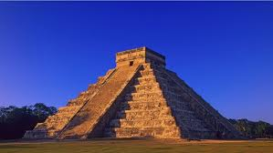Pyramids http://www.photosof.org/view/chichen_itza_aztec_empire_pyramid_in_mexico-hd.html  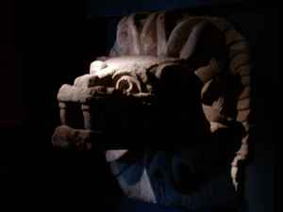  http://www.aztec-history.com/ancient-aztec-religion.html  Food and Farming  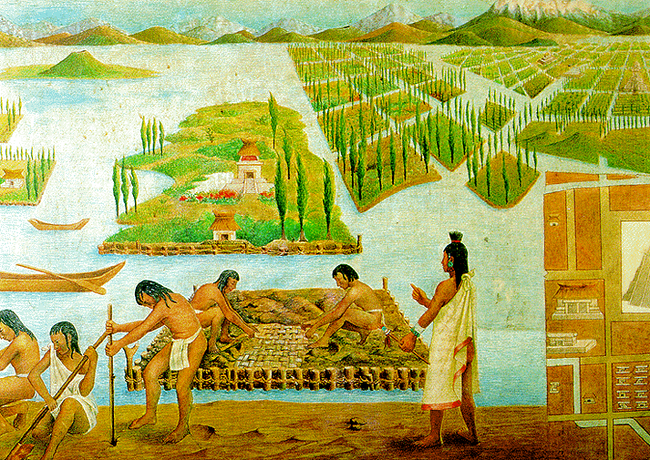 Chinampas  http://anthropogen.com/2011/04/24/chinampa-raised-bed-hydrological-agriculture/ | 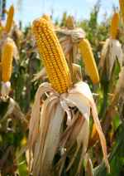 Maize  http://www.aztec-history.com/aztec-food.html  Jobs  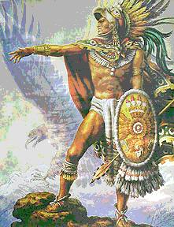 Aztec Warrior  http:/www.solarnavigator.net/history/aztecs.htm

- Acting as a tour guide, explain the different images to the students in detail. Below are the different aspects of the Aztec culture with a link to a website that goes in depth based on the aspect. Students should have notebooks to take notes on their experience
- Religion – http://www.aztec-history.com/ancient-aztec-religion.html
- Farming and Food - http://www.ancient.eu/article/723/
- Job Specialization - http://aztecs.mrdonn.org/professions.html
- At each station (photos), students will complete an activity
- Religion – Students will partake in showing the gods worship through sacred hymns. Students can play music, sing songs or participate in a ritual dance
- Farming and Food – At this station, lay out specific foods that were popular among the Aztec culture (Maize, beans, squash, and tomatoes). Students will see how the Aztecs had a healthy diet.
- Job Specialization – Have a list of jobs in the Aztec culture (child, farmer, soldier, trader, merchant, priest, doctor, and athlete) and cut them individually and place in a hat. Students will take turns in choosing a job out of the hat and will act out the specific job. The other students will try to guess what the job is. After each job is guessed or figured out, explain how that role is viewed in the Aztec culture.
- At the end of the tour, ask students to write 3 journal entries about the different aspects of the Aztec culture. Students should include what they liked /or disliked and why. The journal entry should also include what the students did on their journey (activities completed).
W. 5. 8. – Students are asked to complete 3 journal entries based upon their new information learned from the images and their experiences through the different activities.

