Academic Primary Learning Target: What determines the strength and success of a society, economically, politically and socially?
Academic Standards | RL.5. 11 – Students are asked to analyze an image and then read a specific text that relates to the concepts shown in the image. Students are asked to make connections between the image and text.  SL. 5. 1c. – Students will be participating in a group discussion about the images and text they viewed.  RI. 5. 9 – Students are analyzing two different sources that discuss the same concept. Students will be able to speak knowledgably about the concepts discuss.
IEP Goal | Extra time on activities and assessments.  Directions simplified orally.
Lesson Objective | Students will compare and contrast an image and text that discusses the Aztec practice of Human Sacrifice. After a group discussion, students will create their God or Goddess that includes all aspects from the checklist.
Assessment | Students will complete a graphic organizer to demonstrate the similarities and differences between the image and text they read. Students will create their own God or Goddess that includes all aspects from checklist.
I Can Statement | I can make connections between two different sources that talk about the same idea.  I can make connections amongst the comments of others.  I can create a finished product that paraphrases what I learned.

Instructional Strategies/Learning Tasks | Accommodations/Research Connections
Day 1  1. Project the image attached onto a SMART Board projection system or white board (allows students to circle or label specific details right on the image). Also give students individual copy of image  2. Discussion Questions to ask aloud:  a) What do you see?  -Students identify the green creature and the dismembered body in the center  b) Why do you think the green creature looks different from the rest in the image?  Students identify that the mythical creature is different because it resembles some kind of importance.  c) The Aztecs are surrounding the mythical creature. What could this mean?  Students identify that the Aztec may worship the creature and that it is a part of the Religion aspect of Aztec culture.  Day 2  3. Have students log into an iPad, laptop or desktop computer and type in the URL:  http://www.aztec-history.com/aztec-sacrifice.html  4. Independently, have students read the whole section and take notes in their interactive notebooks. When students get done, they can collaborate with a peer.  5. Students will work on a Venn diagram to compare and contrast the viewed image and text read for 5-15 minutes.  6. Break students into pairs of 2, and share their Venn diagrams with each other for 2-3 minutes  7. Have students arrange their desks or seats into one big circle so that every student can be seen and heard  8. Initiate discussion by asking students:  - What did you read in the text that you see in the image?  - What didn’t you see in the image that you read in the text?  - How do you feel about the Aztec practice of human sacrifice?  Day 3  9. Download the $2.99 app, “Aztec Gods and Mythology Pocket Preference” to the iPads. Students will explore the app  10. Discuss some of the different gods in the Aztec culture and their characteristics/elements.  11. Have students create their own God or Goddess. The assignment must include:  - A picture of the God/Goddess  Write up:  - The God/Goddess’ purpose  - Who worships the God/Goddess  - How are they worshipped  Example on page 3, section 2.  12. Students will present their God or Goddess in a short 3-5 minute presentation. | Day 1  1. Have students gather around the image; either on the floor, at desks, or set location for viewing the image. The image must be seen by every student. Students should bring an interactive notebook for the activity.  2.  a) Have students use the SMART markers or dry erase markers to identify specific details of the image. Circle the images if students do not recognize certain details. Ask students to write down the details in the left page of their interactive notebooks. Students who use computer programs to write assignments/ideas/notes, can create two columns in a Google Doc. Knowledge  b) Write down the ideas students have on the board. Students should do the same in their notebooks or word document. - Evaluation  c) Students take notes in their notebook or Google Doc during visual activity.-Evaluation  *Collect notebooks to give feedback. Give feedback on those using Google Docs as well.*  Day 2  3. Discuss instructions on how to log into devices and remind students the expectations of using the tools.  4. Students will be using the left page in their notebooks or left-hand column to take notes.  5. Diagram is provided on page 4, section 4. Notes taken during activity may be used to complete diagram. Students may type diagram as well. Diagram can be completed on paper provided or in Microsoft Word.  6. Students can be broken off into groups of 2 or 3, depending on the number of class mates.  8. Ask students to share their ideas with the class while adding to their own notebooks, document and diagram.  - Knowledge  - Comprehension  - Evaluation  *Collect notebooks to give students feedback and to those who use Google Docs as well.*  Day 3  9. Provide iPads to each student to allow them to independently explore the Aztec mythology app.  10. Have students discuss their favorite Aztec gods and goddesses with a partner. After 5 minutes, asks students to share with the class.  11. Picture and write up will be completed on the right hand page or column of interactive notebooks.  - Illustration can be hand drawn or computer generated.  - Write up can be hand-written or typed  12. Presentations can be shown by PowerPoint, brochure, poster, or skit to demonstrate the God or Goddess they created. Give students checklist for which the presentation is graded on prior to assignment.  Checklist and reflection: page 5 & 6
Resources and Materials:
- 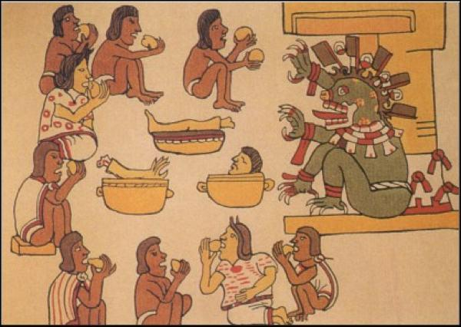 Human sacrifice image - http://i2.wp.com/listverse.com/wp-content/uploads/2012/12/feast.jpg?resize=600%2C426
- Example of interactive notebook
Left page or column  Notes from image:  - Human Sacrifice  - A part of Aztec religion  - Green mythical creature = Important  - Mythical creature = God | Right page or column  Assignment: Illustrate a God or Goddess and discuss your God or Goddess. Include these in your summary:  - Purpose of God/Goddess  - Who worships the God/Goddess  - How they are worshipped.  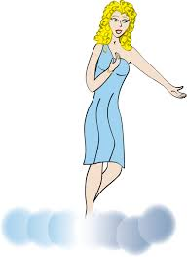  Fluer is the goddess of environment. Goddess Fluer created the beautiful flowers and plants that are found in wilderness. People of New York worship her by planting trees, saving endangered animals and growing beautiful flowers.

3.
- Website where students will be reading about the Aztecs practicing human sacrifice:
http://www.aztec-history.com/aztec-sacrifice.html
- Aztec 4 major Gods/Goddesses’ (characteristics and elements)
http://www.aztec-history.com/aztec-gods.html

- Venn diagram to print off and give to each student to compare and contrast the image and text
Ideas found in text
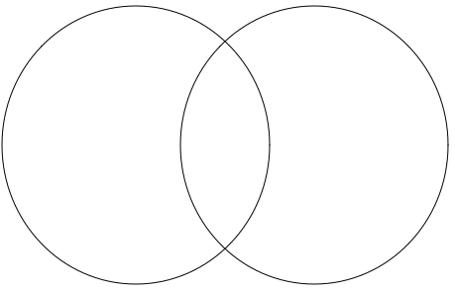
Similarities
Ideas found in image

Name: Date:
Aztec Civilization
Assignment – You will be creating your own god or goddess and completing a brief 3-5 minute oral presentation. Presentations can be shown by:
- PowerPoint
- Brochure
- Poster
- Skit
I can create a finished product that paraphrases what I learned.
Criteria | No  (0) | Yes  (1)
Visual
- Did you include a visual of your God or Goddess?
- Did you use any type of physical piece of work to display your God or Goddess? (i.e. PowerPoint, brochure, poster, etc.)
Content
- Did you describe your God or Goddesses’ purpose?
- Did you identify who worships your God or Goddess?
- Did you explain how your God or Goddess is worshipped?
Neatness
- Did you use color, visuals, or other supplies that were provided in creating your presentation?
Grammar and Spelling
- Is assignment written free of grammatical errors?
- Is the assignment free of misspelled words?
Presenting
- Did you speak loud enough for all your classmates to hear you?
- Did you look at your classmates or teacher when talking?

Total Points:
Reflection:
Based on the total points, how did you do?

What can you do to make your presentation better?

How can I help you make your presentation better?

