Visual Discovery Activity 2
The Conquest of Mexico Paintings
http://www.loc.gov/exhibits/exploring-the-early-americas/conquest-of-mexico-paintings.html
“Arrival of Cortés in Vera Cruz” “The Capture of Tenochtitlan”
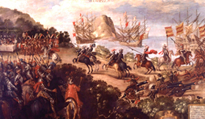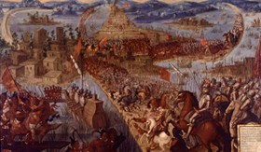
“The Capture of Cuauhtémoc”
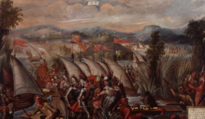
Analyzing Paintings
- Top Left Painting
- Identify the two groups of people; The Aztecs and Conquistadors.
- Students should recognize Hernán Cortés.
- What details of the painting confirm that Cortés and the conquistadors entered the Aztecs homeland?
- Top Right Painting
- Have students Identify the key details that demonstrate the Spanish conquering the capital city, Tenochtitlan
- Students point out weapons used by the Spaniards and Aztecs. Are there any advantages? Disadvantages?
- Have students become aware of the geography of the city.
- Ask your students; Does the geography of the city of Tenochtitlan provide an advantage or disadvantage to the Aztecs when fighting with the Spaniards?
- Bottom Left Painting
- The Capture of Cuauhtémoc occurred after the conquistadors conquered Tenochtitlan.
- Ask students what similarities they see in “The Capture of Cuauhtémoc” and “The Capture of Tenochtitlan.”
- Students should identify the conquistadors weapons and tactics the conquistadors used in both paintings.
ASSIGNMENT
Act-it-Out : Divide the class in halves. Assign a student from one group to play the role as Montezuma II. From the other group, select a student who will play the role as Hernán Cortés. Montezuma II’s group will be the Aztecs and Hernán Cortés’ group will act as the conquistadors. Both groups will discuss their weapons and war tactics. The students will act out the scenes: Montezuma II welcoming Cortés, the capturing of Montezuma, the death of Montezuma that leads to the Aztecs attacking the conquistadors.

CCS: RI. 5. 3. Students take the new information they received from the 3 paintings and are asked to reenact the actions between the Aztecs and conquistadors. Students take concepts from the paintings to properly demonstrate the interactions between the two societies.

