Visual Discovery Activity 3
Hernán Cortés: from Second Letter to Charles V, 1520
http://www.fordham.edu/halsall/mod/1520cortes.asp
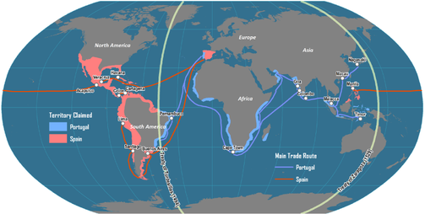
- Present the image of the map on a SmartBoard projector or white board
- Ask students to identify what territories are highlighted in red
- “What country does the red color identify?”
- Hernán Cortés and the conquistadors were explorers from Spain. Have students search what individual was in power during this time period (1520). (Students will be eager to find out first!)
- Present the Second Letter to Charles V that Hernán Cortés wrote in 1520. Divide the letter into sections and give 1 section per student.
- Give 10-15 minutes of reading to allow students to comprehend the broken English text.
- Have each student, in order of the letter, summarize the text they had read
- Ask students: Why do you think Hernán Cortés wrote this letter along with 4 others?
- Recognize that although Hernán Cortés was a powerful individual, the Emperor of Spain was Charles V. The Emperor had made the final decisions of the military

CC:: SL. 5. 5. - Using the map to go along with the letter written by Hernán Cortés to Charles V will allow for greater comprehension. Students use the image to gain better understanding of the conquistadors history and purpose for exploration.

